Contents
PART I. FEASIBILITY STUDY 1
1. Problem Statement 1
3. Feasibility Study: 2
3.1. Technical Feasibility 2
3.3. Economic Feasibility 2
4. Operational Feasibility 3
4. Schedule Feasibility 4
5. Legal and Ethical Feasibility 5
PART II. Requirement Specifications 6
1. Project Objective 6
2. User Requirements 6
3. Functional Requirements 6
4. Non-Functional Requirements 7
PART III. SOFTWARE DESIGN 8
1.DFD 8
2.Structured chart 8
3. Use Case Model 8
4.User Use Cases: 10
5. Entity-Relationship Diagram (ER Diagram) 11
Diagram Summaries 12
PART IV : IMPLEMENTATION 13
1. Technologies Used 13
2. Coding Process 14
PART V: TESTING & CODING 15
1. Black Box Testing 15
2. White Box Testing 15
3. Integration Testing 16
4. Smoke Testing 16
PART VI: CONCLUSION 17

PART I. FEASIBILITY STUDY

1. Problem Statement
The RU CSE HUB app seeks to address the fragmentation of essential resources and communication within the Computer Science and Engineering (CSE) department at Rajshahi University. Currently, students and faculty lack a streamlined, centralized platform for accessing academic resources, department schedules, notices, and collaborative spaces, leading to missed updates, reduced engagement, and inefficient communication.
RU CSE HUB will unify these resources and channels into one accessible app, transforming the department’s digital ecosystem. By providing instant access to schedules, course materials, job postings, notifications, and real-time chat, RU CSE HUB aims to simplify resource access, enhance engagement, and support a more connected, productive CSE community.

2. Background Study
In the evolving landscape of higher education, the demand for streamlined, digital solutions is at an all-time high. For Computer Science and Engineering (CSE) students and faculty at Rajshahi University, accessing academic resources, timely updates, and communication channels remains fragmented across multiple platforms and manual processes. This dispersion creates hurdles in staying informed, accessing course materials, engaging in departmental activities, and forming connections with peers and alumni.
Centralized digital platforms have become essential in addressing these challenges, providing a seamless flow of information, enhancing engagement, and creating a connected academic ecosystem. In line with these trends, RU CSE HUB aims to unify critical resources and communication tools into a single, user-friendly platform, tailored to the needs of the CSE department. This app offers on-demand access to schedules, study materials, notifications, job postings, and real-time chat, fostering a collaborative, modern learning environment.
RU CSE HUB aligns with Rajshahi University’s vision of digital modernization, setting a precedent for a more connected, efficient academic experience and positioning the department at the forefront of educational innovation.

3. Feasibility Study:
A feasibility study assesses the practicality of a project or system. This analysis determines if the proposed app, RU CSE HUB, is viable in terms of its technical, economic, operational, and schedule aspects. Below is a feasibility study for your app in the context of Software Engineering.

3.1. Technical Feasibility
This section evaluates whether the app can be developed using current technology and if the development team has the required skills and resources.

Technical Requirements:
- Platform: Android, iOS (via Flutter) for cross-platform compatibility.
- Backend: Firebase or Google Cloud for database management and user authentication.
- Third-party Services: APIs for job listings, coding platform integration, notifications, and chat systems.
- Libraries/Frameworks: Flutter for the frontend UI, Firebase for backend services (Authentication, Firestore), Push Notifications (Firebase Cloud Messaging), and Real-Time Chat (Firebase Realtime Database).
- Hardware Requirements: Cloud servers for hosting and storing data (Firebase, Google Cloud, etc.).
- Developer Expertise: Flutter development, Firebase integration, backend development using Google Cloud, handling APIs.

3.2 Technical Challenges:
- Real-Time Chat: Implementing real-time communication can be complex and might require dealing with scalability, data consistency, and message synchronization across devices.
- Push Notifications: Ensuring real-time push notifications are delivered efficiently.
- Integrating Multiple APIs: Seamless integration of external APIs (job platforms, coding websites) with your app might require continuous maintenance and updates.

Conclusion:
The technical aspects of the app are feasible with existing technologies (Flutter, Firebase, APIs). However, real-time chat and handling notifications across platforms need careful planning.

3.3. Economic Feasibility
This section assesses the financial viability of the app, including development costs, potential revenue streams, and ongoing maintenance costs.

Costs:
- Development Costs:
  - Developer salaries (Flutter developers, backend developers).
  - API integration and licensing fees for external services (e.g., job platforms).
  - Hosting and storage (Firebase/Google Cloud).
- Maintenance Costs:
  - Server hosting and database maintenance.
  - Regular updates and bug fixes.
  - User support and admin panel maintenance.

3.4 Revenue Generation (if applicable):
- Ad Revenue: Placement of ads within the app could generate revenue, particularly in the job section or resource areas.
- Freemium Model: Offering premium features (e.g., job posting by companies, exclusive resources) as in-app purchases.
- University Funding: The app could be funded by the university to support its students and faculty.

3.5 Cost-Benefit Analysis:
- Costs: The initial investment is substantial, considering the development, integration of multiple features, and maintenance.
- Benefits: If the app gains popularity and user engagement increases, it could be self-sustaining, especially with ad revenue and university support.

Conclusion:
The app's development and ongoing costs are manageable within a reasonable budget, especially if supported by university funding or additional revenue streams.

4. Operational Feasibility
This section assesses whether the app can be successfully implemented and maintained within the organizational and operational context of the university.

User Needs:
- The app should fulfill the needs of students, teachers, and faculty members by providing a centralized platform for all essential information (schedules, job opportunities, resources, etc.).
- It should improve communication and collaboration within the CSE department.

User Interface (UI):
- Usability: The app’s interface must be user-friendly and intuitive, especially since it targets university students and faculty, who might not be highly tech-savvy.
- Design: The Light Neumorphism design should be aesthetically pleasing, easy to navigate, and functional across devices.

Operational Challenges:
- User Adoption: Encouraging students and faculty to actively use the app.
- Content Maintenance: Regularly updating content like job listings, course schedules, office notices, and alumni data.
- System Reliability: Ensuring the app operates smoothly with minimal downtime for both users and administrators.

Conclusion:
The app is operationally feasible, with proper support for user engagement, content updates, and system reliability. It will require continuous effort from the university to maintain and update content, ensuring the app remains relevant and useful.

4. Schedule Feasibility
This section evaluates whether the app can be developed and deployed within a realistic timeframe.

Project Phases and Timeline:
- Requirement Analysis and Design: 4-6 weeks
  - Finalize requirements, features, and user flow.
  - Design wireframes and UI/UX.
- App Development: 8-12 weeks
  - Frontend (Flutter) and Backend (Firebase) development.
  - Implementing key features: Authentication, Notification system, Post system, and real-time chat.
- Testing: 4 weeks
  - Perform unit testing, integration testing, and user acceptance testing.
  - Resolve bugs and optimize performance.
- Deployment: 2 weeks
  - Deploy the app to the Play Store and App Store.
  - Launch and gather feedback for future improvements.

Timeline for Initial Version:
- Total Estimated Time: 4-6 months for the initial version with core features.
- Future Updates: Continuous improvement and updates can be planned based on user feedback.

Conclusion:
The timeline is feasible, with a clear roadmap for each phase. However, it is important to factor in possible delays and unforeseen challenges during development.

5. Legal and Ethical Feasibility
This section assesses the legal and ethical considerations of developing and maintaining the app.

Legal Considerations:
- Data Privacy: The app will handle personal data (e.g., student and faculty details). Ensure compliance with data protection regulations like GDPR or local laws on data privacy.
- Copyrights: Ensure that content shared within the app (e.g., course materials, coding challenges, job listings) is properly licensed or used with permission.
- User Agreements: Define terms of use, privacy policies, and disclaimers for app users.

Ethical Considerations:
- Equal Access: Ensure that all students, regardless of their background or resources, have equal access to the app and its features.
- Content Moderation: Handle posts and group chats to avoid inappropriate content and ensure a respectful environment.

Conclusion:
The app can be legally and ethically viable, but careful attention must be paid to data privacy, copyright issues, and ensuring the app is inclusive and moderated.

Creating a comprehensive software design for RU CSE HUB involves several key diagrams. Here’s an outline of each, along with a detailed description of how they apply to the app.

PART II. Requirement Specifications

1. Project Objective
The RU CSE HUB app aims to centralize essential information and resources for students and faculty within the Department of Computer Science and Engineering at RU. Its objective is to simplify access to academic schedules, course details, faculty information, job listings, coding resources, interview preparation, and communication tools. The app also provides a platform for real-time announcements, notifications, and social engagement, facilitating a cohesive and supportive environment for the CSE community.

2. User Requirements
- Registration and Login: Users register with their email and password, or potentially social media accounts.
- Profile Management: Users can update profiles with personal information such as name, batch, and hall.
- Teachers and Student Info: Users need access to faculty information, student lists (with privacy controls), and alumni records.
- Routine and Office Info: Users require easy access to office contact information, bank details, and class routines.
- Courses and Job Listings: Users should be able to view course details, syllabi, and job opportunities related to the CSE field.
- Coding Platforms and Contests: Users want links to coding platforms and notifications of upcoming coding contests.
- Library of PDFs: Users need a PDF library of study materials categorized by subject and semester.
- Notices and Notifications: Users need access to routine updates and notifications on relevant changes.
- Social Engagement: Users should be able to post information, ask questions, and participate in a group chat system.
- Interview and MCQ Prep: Users should have access to interview questions and software-related MCQ quizzes.

3. Functional Requirements

User Management and Authentication
- User Registration and Login: Register with email/password or social media; authenticate securely using Firebase.
- Profile Management: Users can create and update their profiles with fields like name, phone number, batch, and hall.
- Authentication Security: Protect user data and provide secure login using Firebase authentication.
- Admin Control: Admins can manage content, disable user accounts, and update app information.

Teachers and Student Information
- Teacher Profiles: Display teacher profiles with qualifications, office hours, and contact info.
- Student Privacy Controls: Show limited student information, protecting sensitive data.
- Alumni Directory: Include comprehensive alumni information with privacy options for sensitive data.

Office and Routine Management
- Office Information: List administrative offices, contacts, and service details.
- Routine Display: Allow users to view/download routines based on semester or year.
- Office Notices and Banking Info: Display administrative notices and office banking details.

Courses and Job Listings
- Course Management: Show course details, prerequisites, and syllabus.
- Job Portal: Provide job listings and links to relevant job sites for CSE roles.

Coding Platforms
- Platform Links: Integrate links or APIs to popular coding sites like LeetCode, CodeChef, etc.
- Contest Alerts: Notify users about upcoming contests.

CSE-Related PDFs
- PDF Library: Organize PDFs by subject and semester with download options.

Notices and Notifications
- Class Routine Notices: Display notices and notify users via push notifications.
- Notification System: Provide alerts for updates, posts, and messages.

Post and Group Chat Systems
- Post System: Allow users to post announcements, questions, and departmental information.
- Group Chat: Enable real-time group or one-on-one chats for topic discussions.

Interview and MCQ Prep
- Interview Preparation: Provide resources for interview questions and tips.
- MCQ Preparation: Offer a collection of MCQ quizzes related to software job preparation.

4. Non-Functional Requirements
- User-Friendly Interface: Ensure intuitive navigation and accessible design.
- Security and Privacy: Secure Firebase authentication, role-based access control, and data privacy.
- Admin Dashboard: A secured admin panel for managing users, content, and settings.
- Performance and Scalability: Build to handle a growing user base and increased content.
- Testing and Debugging: Thorough testing to ensure reliability and correct any bugs.

The testing and debugging process for RU CSE HUB is designed to ensure reliability, usability, and robustness. The testing strategy includes various techniques—Black Box Testing, White Box Testing, Integration Testing, and Smoke Testing—to provide comprehensive coverage and identify potential issues at all levels of the application.

PART III. SOFTWARE DESIGN

1.DFD

2.Structured chart

3. Use Case Model
User Use Cases:
- View & Update Profile: Users can access and modify their personal information.
- Delete User: Users have the option to delete their account.
- View User Information: Users can view their own information.
- Office, Job, Course & Routine: Users can view information about offices, job opportunities, courses, and routines.
- View Online Platforms & CSE: Users can access online platforms and resources related to Computer Science and Engineering (CSE).
- Announcement/Chat: Users can view announcements and participate in chats.
- Interview/MCQ Question: Users can access interview questions and multiple-choice questions.
- Notification: Users receive notifications about updates, announcements, and other relevant information.
Admin Use Cases:
- User Register: Admins can register new users.
- Update & Delete User: Admins can update and delete existing user accounts.
- Course & Routine Management: Admins can manage course information and schedules.
- Post Announcement/Chat: Admins can post announcements and initiate chats.
- Post Interview/MCQ Question: Admins can post interview and MCQ questions.
Overall Use Case: The app appears to be a centralized platform for CSE students and faculty at RU (Rajshahi University). It provides a variety of features to facilitate communication, information sharing, and resource access.
Additional Insights:
- The diagram suggests that there is a separation of roles between Admins and Users. Admins have more control over the platform's content and user management.
- The app seems to be designed to provide a comprehensive solution for CSE-related activities, including academic resources, job opportunities, and communication channels.
Potential Improvements:
- Enhanced User Interface: Consider a more user-friendly interface with clear navigation and intuitive layouts.
- Search Functionality: Implement a robust search feature to help users find specific information quickly.
- Interactive Features: Incorporate interactive elements like discussion forums or collaborative tools to foster engagement.
- Mobile Optimization: Ensure the app is optimized for mobile devices to cater to a wider user base.

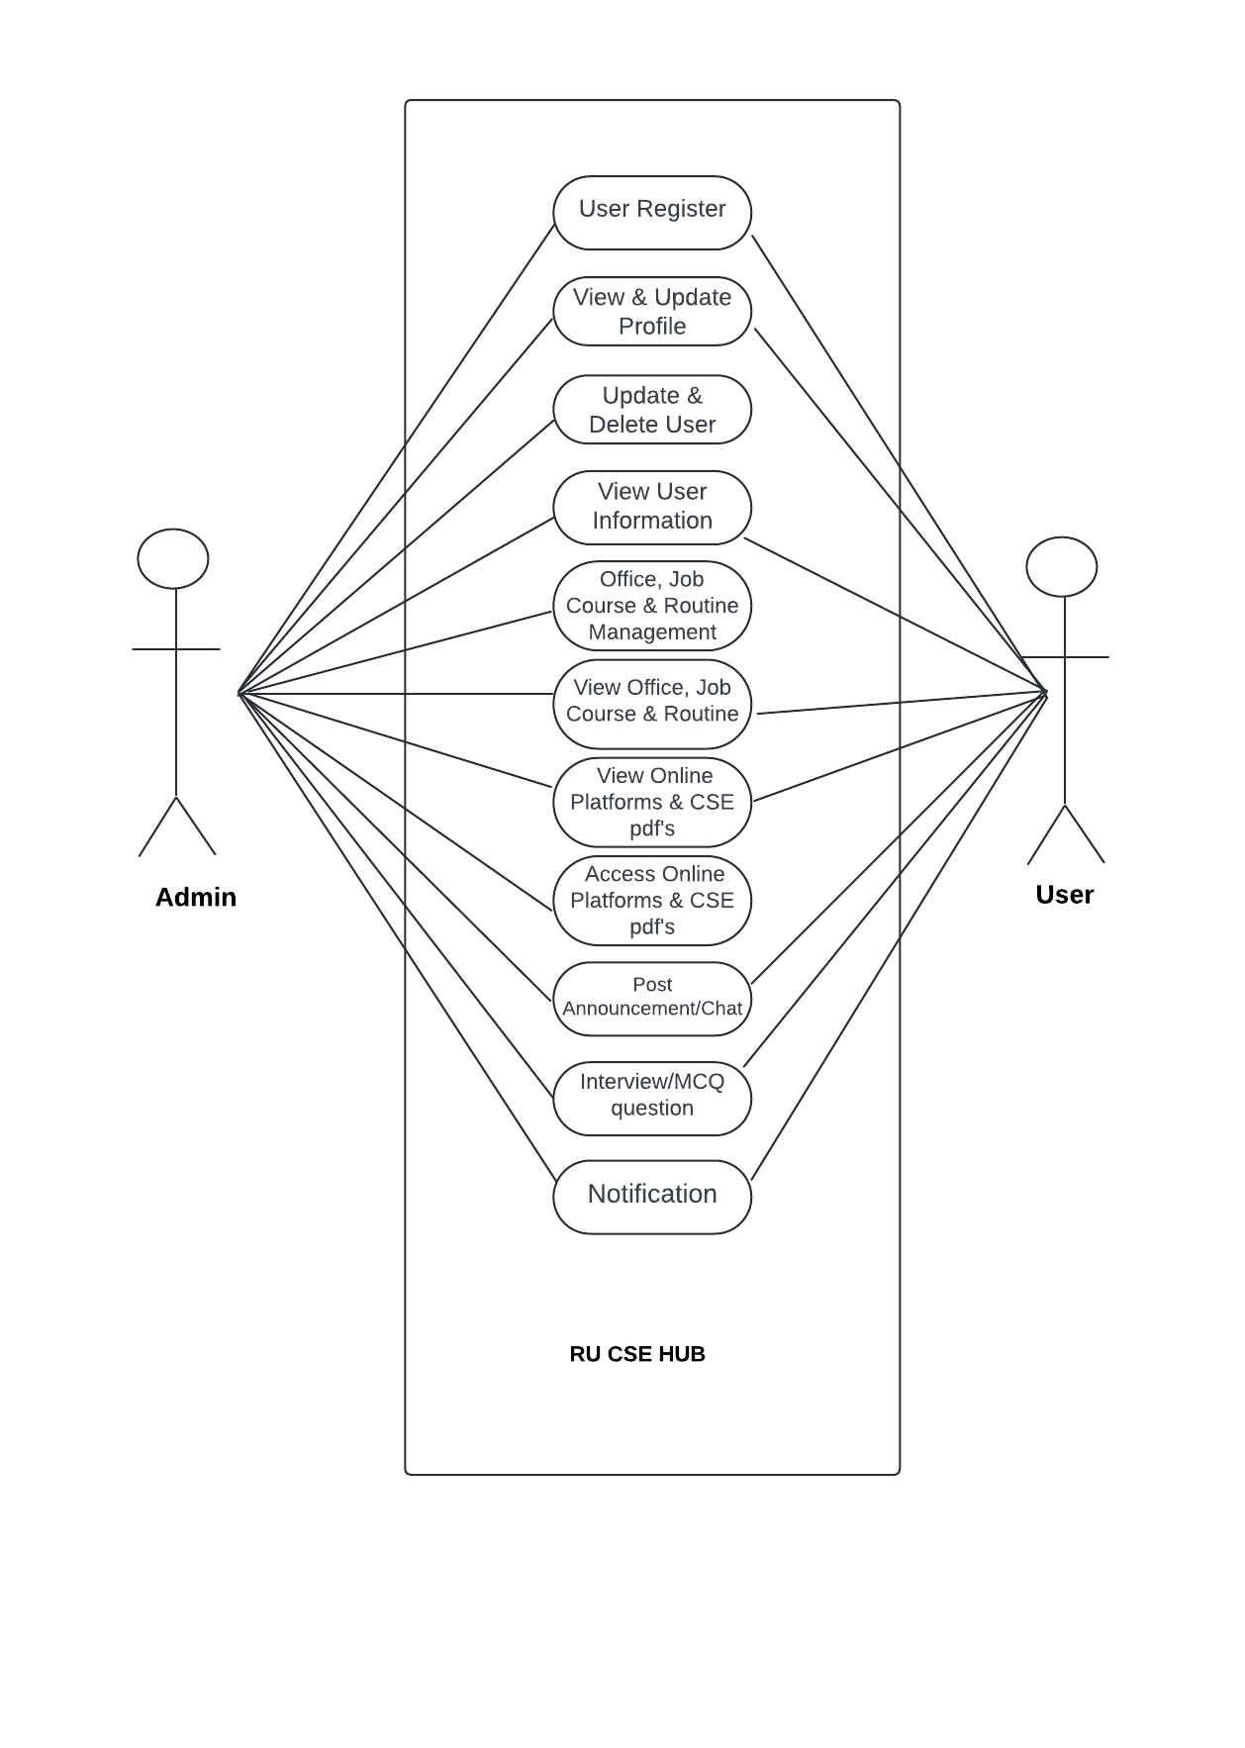

4.User Use Cases:
- View & Update Profile: Users can access and modify their personal information.
- Delete User: Users have the option to delete their account.
- View User Information: Users can view their own information.
- Office, Job, Course & Routine: Users can view information about offices, job opportunities, courses, and routines.
- View Online Platforms & CSE: Users can access online platforms and resources related to Computer Science and Engineering (CSE).
- Announcement/Chat: Users can view announcements and participate in chats.
- Interview/MCQ Question: Users can access interview questions and multiple-choice questions.
- Notification: Users receive notifications about updates, announcements, and other relevant information.
Admin Use Cases:
- User Register: Admins can register new users.
- Update & Delete User: Admins can update and delete existing user accounts.
- Course & Routine Management: Admins can manage course information and schedules.
- Post Announcement/Chat: Admins can post announcements and initiate chats.
- Post Interview/MCQ Question: Admins can post interview and MCQ questions.
Overall Use Case:
The app appears to be a centralized platform for CSE students and faculty at RU (Rajshahi University). It provides a variety of features to facilitate communication, information sharing, and resource access.
Additional Insights:
- The diagram suggests that there is a separation of roles between Admins and Users. Admins have more control over the platform's content and user management.
- The app seems to be designed to provide a comprehensive solution for CSE-related activities, including academic resources, job opportunities, and communication channels.
Potential Improvements:
- Enhanced User Interface: Consider a more user-friendly interface with clear navigation and intuitive layouts.
- Search Functionality: Implement a robust search feature to help users find specific information quickly.
- Interactive Features: Incorporate interactive elements like discussion forums or collaborative tools to foster engagement.
- Mobile Optimization: Ensure the app is optimized for mobile devices to cater to a wider user base.

5. Entity-Relationship Diagram (ER Diagram)

Entities
- User: Stores user details like ID, name, email, and role (Student, Teacher, Admin).
- Teacher: Contains details such as ID, name, department, and contact.
- Student: Stores student-specific details like batch, roll number, and course.
- Job: Represents job listings with fields for company name, title, description, and application link.
- Notice: Office notices with details like title, description, and posted date.
- Message: Chat messages with attributes for content, timestamp, and sender ID.
- Resource: PDF and course materials linked to semesters or courses.

Relationships
- User “sends” Message.
- Admin “creates” Job, Notice, and Resource entries.
- Student and Teacher can “access” Resource.
- Student and Alumni can “view” Job postings.

6.Diagram Summaries
To provide visual clarity for each of these:
- DFD will showcase data movement between modules.
- Structure Chart represents the hierarchy of functional modules.
- Use Case Diagram outlines user interaction with each feature.
- Sequence Diagram provides a step-by-step view of how real-time chat functions.

- ER Diagram visually captures the relationships and data structure among key entities.

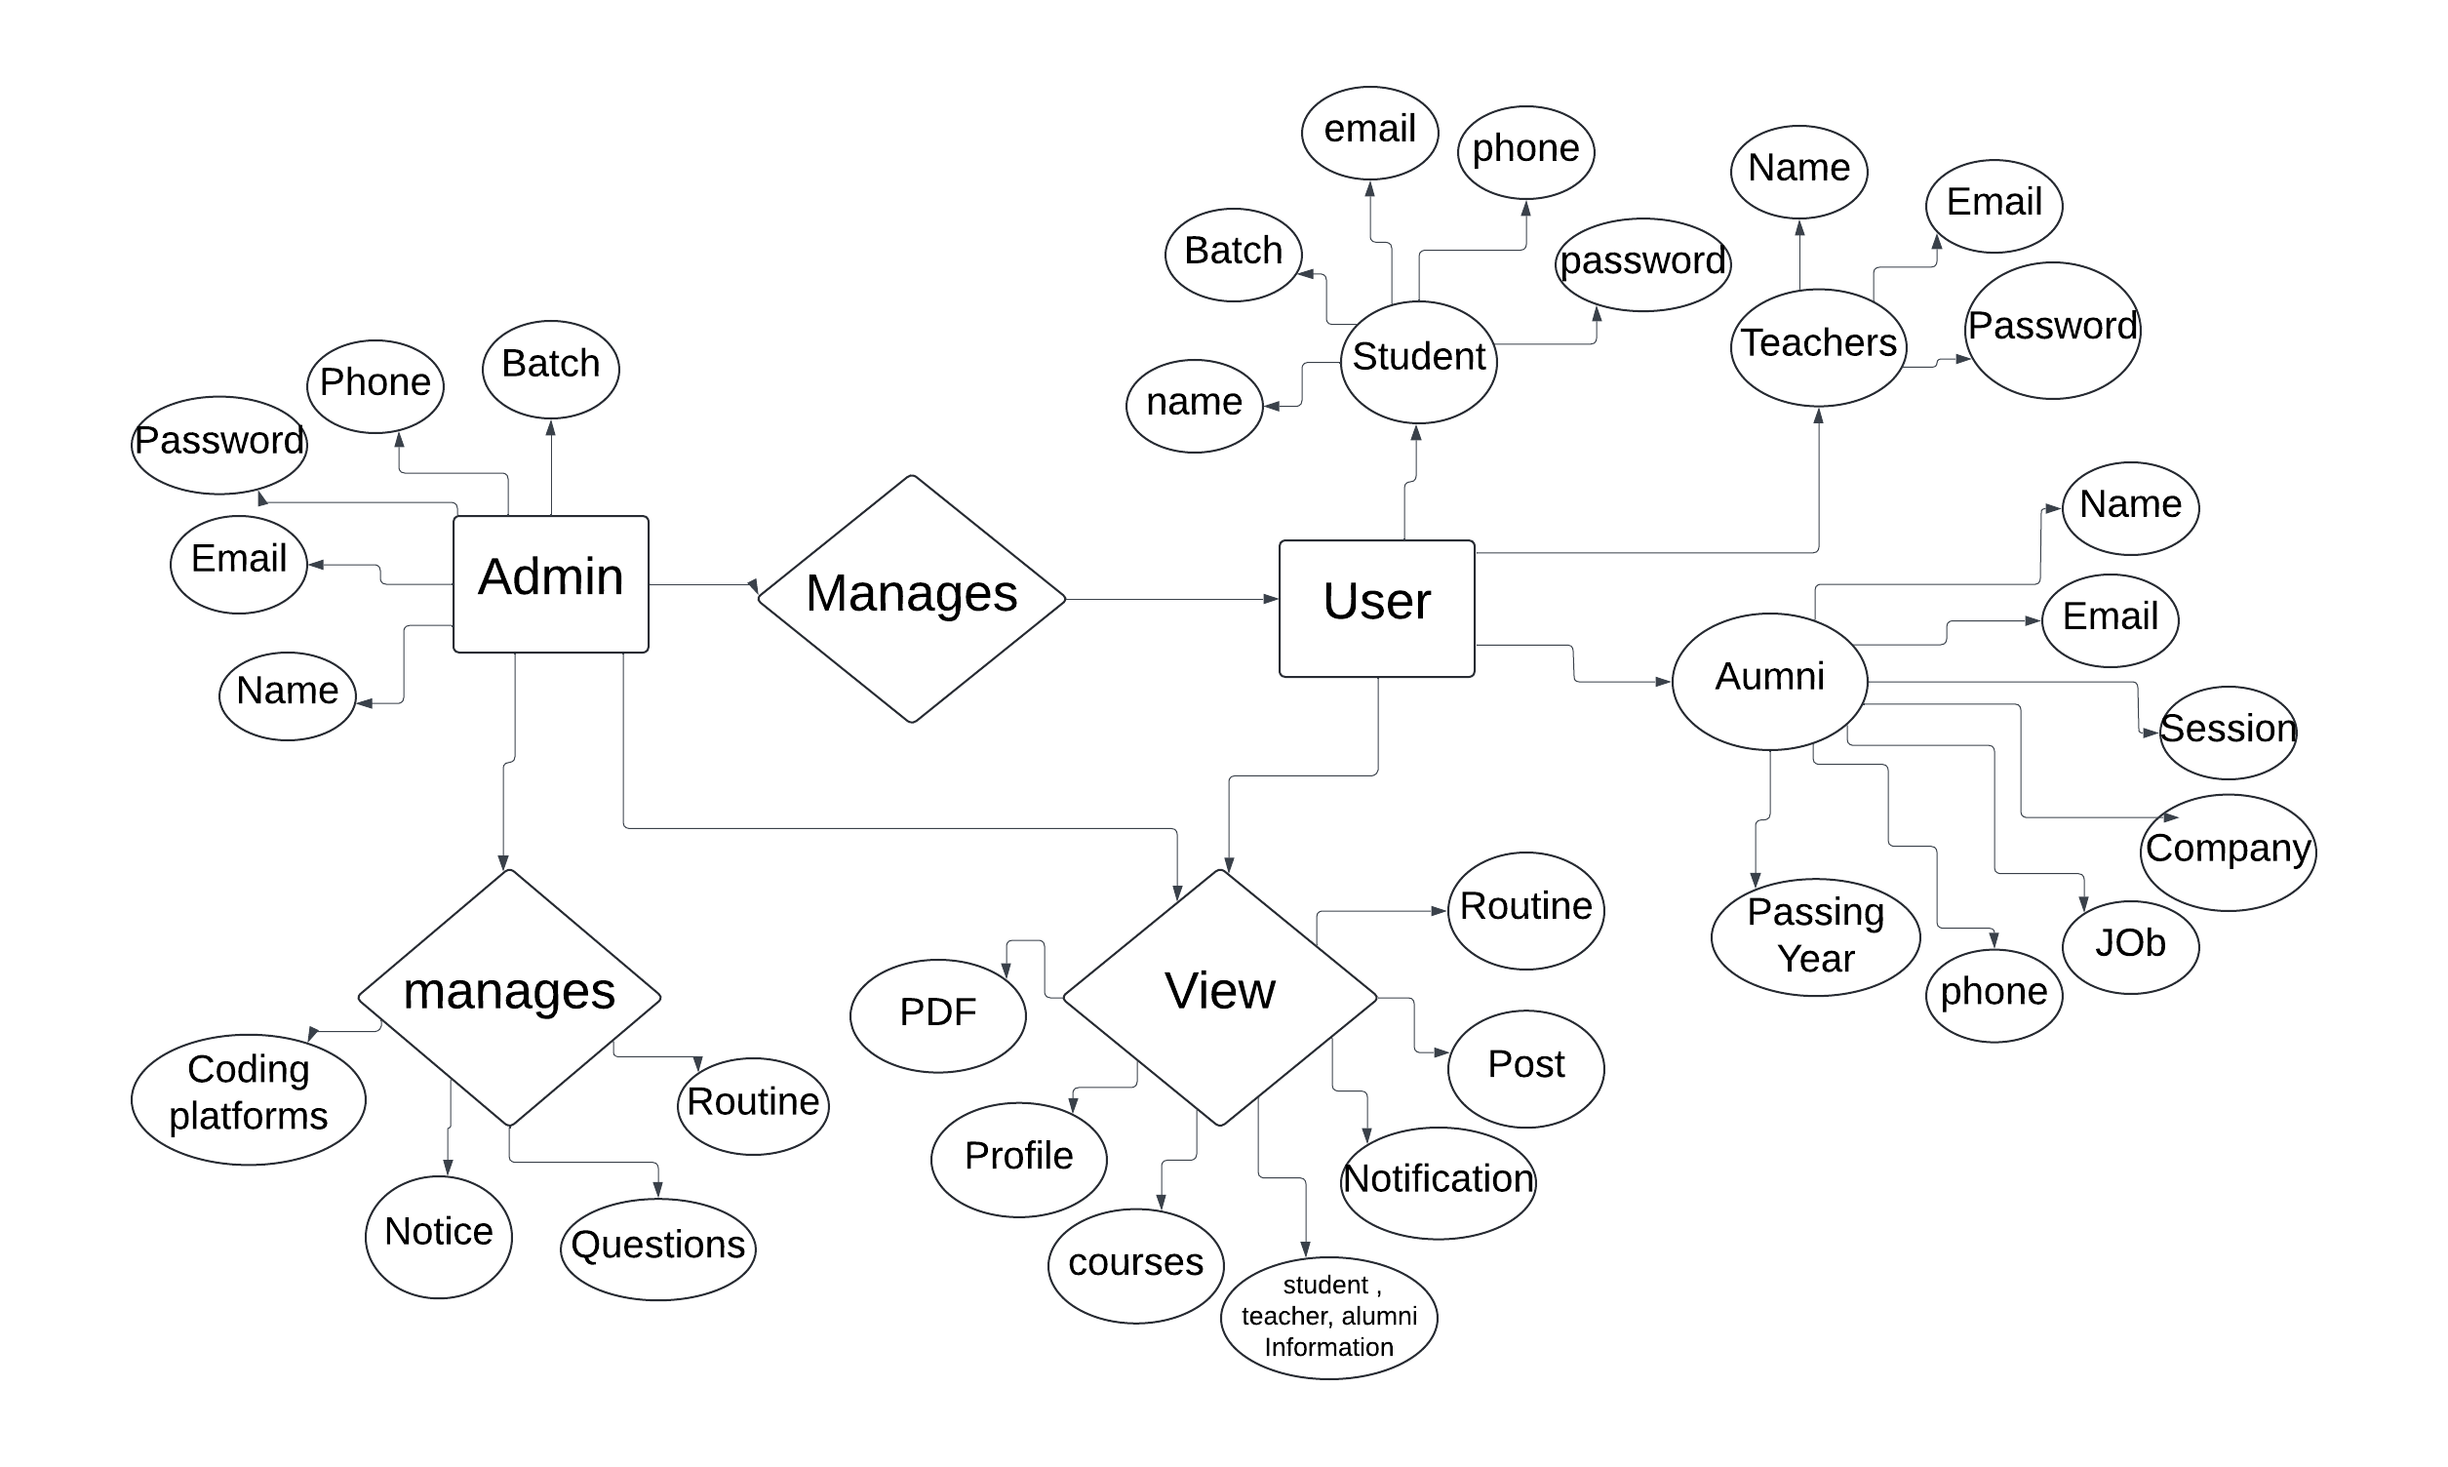

PART IV : IMPLEMENTATION

RU CSE HUB, developed for the Computer Science and Engineering department of Rajshahi University, is built with Flutter and Firebase to provide students and faculty with a comprehensive platform for academic resources, office communications, schedules, job listings, and collaborative tools like group chats. Below is the implementation breakdown, covering Technologies Used and Coding Process.

1. Technologies Used
RU CSE HUB’s technical foundation leverages cross-platform client-side, server-side, and cloud-based database solutions, enabling seamless integration and user experience.

1.1 Client-Side
Flutter: Chosen for its cross-platform capabilities, Flutter enables development for both iOS and Android from a single codebase. It supports:
Responsive User Interface: Ensuring a consistent and accessible design across devices.
State Management: Using packages like Provider and Riverpod for efficient state management and real-time updates.
Push Notifications: Integrated via Firebase Cloud Messaging for real-time alerts on posts, updates, and chat messages.

1.2 Server-Side
Firebase Cloud Functions: Serverless backend logic is handled by Firebase Cloud Functions, allowing scalable execution without managing servers.
Authentication: Provides secure user sign-ins and access control for different roles within the app.
Notification Management: Triggers push notifications for various events like new posts, messages, or office notices.
Data Validation: Ensures data integrity across the platform through backend validation and business logic.

1.3 Database
Firebase Firestore: A NoSQL database optimized for real-time, structured data storage. Firestore’s capabilities support:
User Profiles and Content: Including information for teachers, students, and alumni.
Real-Time Chat: Group chat capabilities with instant syncing across user devices.
Office Notices and Posts: Stored for quick retrieval and real-time updates.
Firebase Storage: Provides secure media storage for larger files such as profile pictures and shared documents, accessible directly within the app.

2. Coding Process
The coding process for RU CSE HUB follows a structured workflow that includes Code Development, Code Review, and Version Control, ensuring efficient development, quality control, and project maintenance.

2.1 Code Development
Architecture: Following a Model-View-Controller (MVC) pattern, creating a modular structure that separates data handling, user interface, and business logic.
UI and UX Design: Flutter widgets are customized to ensure a responsive, user-friendly experience. Specific UI components are crafted for features like chat, notifications, and profile management.
Authentication and Data Operations: Firebase Authentication and Firestore SDKs enable secure login and CRUD operations, making real-time data interactions smooth and reliable.

2.2 Code Review
Peer Review Process: All code undergoes peer review to detect potential issues, optimize performance, and adhere to best practices. Team members conduct reviews through pull requests, with suggestions and approvals documented.
Linting and Testing: Automated linting and consistent code formatting help maintain quality. Unit and widget tests, conducted with Flutter's testing suite, ensure that core functionalities perform as expected before release.

2.3 Version Control
Git and GitHub: Git is used for version control, with GitHub managing the repository, facilitating collaboration, and tracking issues and releases.
Branching Strategy: A Gitflow strategy with dedicated branches for features, fixes, development, and production to maintain a clean and organized codebase.
Continuous Integration and Deployment (CI/CD): GitHub Actions automate testing and build processes, while deployments to Firebase and app stores are managed for timely and reliable updates.
RU CSE HUB’s implementation is optimized for scalability, security, and real-time user interactions. This structured approach enables a seamless experience and reliable application performance, supported by best practices in development, review, and deployment.

PART V: TESTING & CODING

1. Black Box Testing
Black Box Testing focuses on evaluating the app’s functionality without needing to examine the code itself. This technique ensures that user interactions align with expected behaviors.
- Objective: Validate that each feature (e.g., login, group chat, notifications) functions correctly based on requirements.
- Approach: Testing is conducted from an end-user perspective, focusing on inputs and expected outputs for each feature, ensuring ease of use and expected results.
- Test Cases: For instance, scenarios are created to verify that correct credentials allow login, invalid credentials trigger appropriate error messages, and notifications are received accurately for new posts or messages.
- Tools Used: Tools like Firebase Test Lab automate black box testing across multiple device configurations, helping identify and rectify device-specific issues, ensuring a consistent user experience across Android and iOS.

2. White Box Testing
White Box Testing, or structural testing, involves analyzing the app’s internal code structure to ensure it operates as intended and adheres to performance standards.
- Objective: Verify code correctness, optimize algorithms, and identify performance bottlenecks.
- Approach: Tests focus on code paths, loops, and conditions within each module, ensuring that methods are efficient and maintainable. Functions related to real-time chat, data synchronization, and Firebase integration are scrutinized to maintain performance and data consistency.
- Code Coverage: Coverage metrics ensure that essential code areas, particularly critical functions like authentication, chat, and notifications, are fully tested.
- Tools Used: Flutter DevTools and SonarQube are used to conduct code analysis, measure code coverage, and ensure that the code meets quality standards and is free of performance bottlenecks.

3. Integration Testing
Integration Testing ensures that different modules in RU CSE HUB work together seamlessly, particularly when multiple Firebase services are interconnected.
- Objective: Test the interaction between features, such as how the authentication system integrates with Firestore for profile management or how Cloud Messaging triggers notifications.
- Approach: Tests verify that data flows smoothly across modules. For example, when a user posts a notice, the system should simultaneously update the Firestore database, trigger a Cloud Function, and send a push notification to subscribers.
- Complex Scenarios: Testing scenarios simulate real-life interactions, such as concurrent users accessing the group chat, posting updates, or reacting to notifications, to confirm system resilience and stability.
- Tools Used: Firebase Emulator Suite is employed to simulate interactions with Firebase services locally, facilitating comprehensive integration tests without impacting production data.

4. Smoke Testing
Smoke Testing, or “Build Verification Testing,” validates that the core functionalities of RU CSE HUB are functioning after each build or update. This approach ensures a stable build that allows further testing without immediate errors.
- Objective: Verify that the primary features—such as login, home screen navigation, notifications, and chat—are working correctly post-deployment.
- Approach: Each new build undergoes a quick set of tests to validate core functionality, ensuring that essential features load and operate without failure. This testing identifies any immediate issues that could block further testing.
- Continuous Deployment: Smoke tests are integrated into the CI/CD pipeline, automatically running on each build through GitHub Actions to ensure that updates do not introduce critical failures.
- Tools Used: Firebase Test Lab and Flutter Driver automate smoke testing to verify that the latest build is functional on both Android and iOS platforms.
By following these structured testing and debugging approaches, RU CSE HUB ensures high-quality performance, reliability, and an optimized user experience. Each testing phase is carefully planned and automated where possible, allowing quick identification and resolution of issues before release. This comprehensive approach also supports scalable updates and smooth functionality across platforms.

PART VI: CONCLUSION

Based on the detailed feasibility study and software design provided, the RU CSE HUB project appears to be a well-planned and comprehensive application that addresses the needs of the Computer Science and Engineering (CSE) community at Rajshahi University.
The key conclusions from the analysis are:
1. Technical Feasibility: The app can be developed using existing technologies like Flutter, Firebase, and various APIs. While there are some technical challenges, particularly around implementing real-time chat and efficient push notifications, the development team has the required skills and resources to address these.

2. Economic Feasibility: The development and maintenance costs are manageable, especially with the potential for revenue generation through ad placements, a freemium model, or university funding. The cost-benefit analysis suggests the app can be self-sustaining in the long run.

3. Operational Feasibility: The app is designed to meet the specific needs of CSE students and faculty, with a user-friendly interface and robust content management. User adoption and ongoing content updates will be crucial for the app's long-term success.

4. Schedule Feasibility: The proposed timeline of 4-6 months for the initial version with core features is reasonable, given the clear roadmap and project phases outlined.

5. Legal and Ethical Feasibility: The app must comply with data privacy regulations and ensure ethical considerations around content moderation and equal access, but these aspects can be addressed through appropriate policies and controls.

Overall, the RU CSE HUB project appears to be a well-thought-out and viable solution that can significantly improve the digital ecosystem and communication within the CSE department at Rajshahi University. With a strong focus on user requirements, comprehensive features, and a sound technical and operational foundation, the app has the potential to become a valuable resource for the CSE community.

